Part D – Selling cats
4.0 Staffing for businesses selling cats
There must be adequate staffing to feed and socialise kittens every 4 to 5 hours over a 16 hour period.

Cats must not be left for long periods without being assessed. Cats must be checked at least once in 8 hours during periods when the premises are closed, every 4 hours during normal opening hours and at least once in the overnight period outside normal opening hours.

Required higher standards for staffing

- There must be adequate staffing to undertake more frequent checks than required by the minimum standard.

How do you meet this standard?

Inspectors comments –

5.0 Suitable environment for selling cats
Businesses must prevent risk of injury, illness and escape.

All windows must be escape and entry proof at all times.

Doors must have secure latches or other closing devices.

Enclosures must be arranged to ensure separated animals are not in direct contact.

Units and exercise areas must open onto secure corridors or other secure areas.

Environmental conditions for cats (including enclosure sizes)

For kittens under 26 weeks, see the dimensions in the minimum enclosure size you should use.

Cats over 26 weeks must be kept in cattery-style pens. Follow the minimum standards guidance on providing boarding for cats.

Cat units must be large enough to allow for separate sleeping and activity areas. The unit must allow each cat to be able to walk and turn around without touching the sides of the unit. The cats must have sufficient room to play, stand on their hind limbs and to lie down without touching another individual.

The unit size required must increase in relation to the size and number of cats housed at any one time. The length and width must be sufficient to allow all the cats to lie outstretched without their noses or tails touching the walls or other individuals.

In certain circumstances it is permissible to have separate exercise areas to sleeping areas but in such cases cats must be given access to the exercise area at least 4 times a day. Any separate exercise area must be fully cleaned and disinfected between use by different litters of cats.

Cats must have access to a variety of levels (for example shelving) in their runs unless advised differently due to a medical condition (for example cage rest). Raised areas must be easily accessible and ramps or steps may need to be used for very young or old cats.

Cats kept in a domestic premises may be kept in one room, providing the size of this room meets the minimum enclosure sizes for cats. Litters of kittens or cats from different sources must not be housed in the same room. If queens are already in a social group in the house, their litters may mix.

Bedding and substrate for cats

Cats must have a warm, soft, sleeping area, away from their litter tray and food. Bedding must be capable of being easily cleaned, disinfected and all bedding material in use must be clean, non-irritant and dry. Any bedding must be soft and absorbent.

All cats must be provided with a bedding area or bench, to allow the animal to lie comfortably.

Temperature for cats

For adult cats, the temperature in the sleeping area must stay between 15°C and 26°C.

Kittens must be provided with additional effective and safe heat sources. Nursing queens must have the opportunity to move away from the kittens and the additional heat source. Kittens without a queen require higher temperatures.

Minimum enclosure size for kittens up to 26 weeks of age

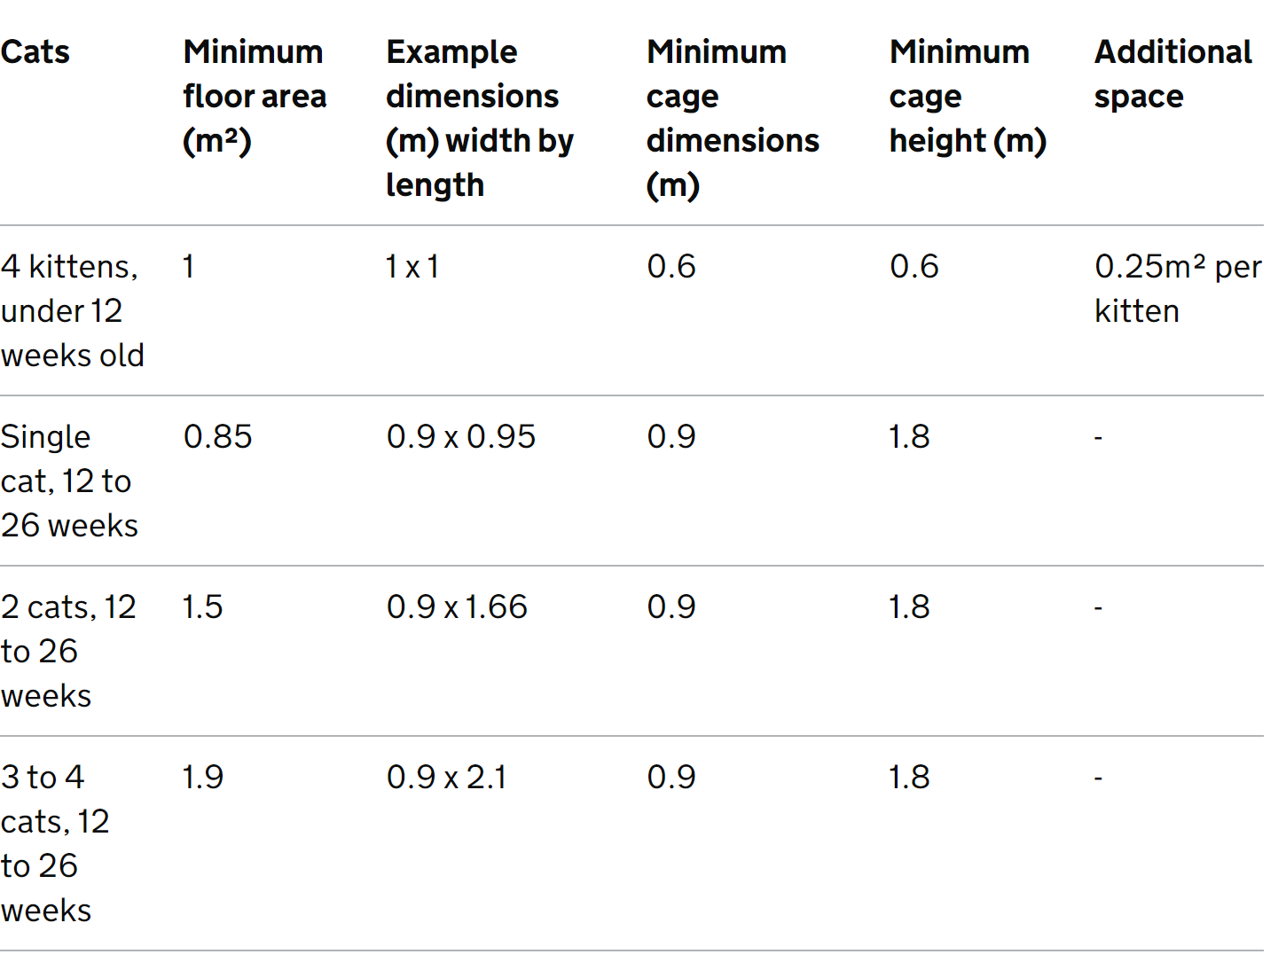

Cleaning cats and housing

Cats must be separated from the area being cleaned, for example placed in a cat carrier or separate unit.

Where required or beneficial to the individual cats, adequate routine grooming and other health regimes must be carried out, for example cleaning eyes or keeping long fur from matting.

Moveable items must be removed for cleaning at least weekly.

Litter trays must be completely emptied, cleaned and disinfected at least once a week or more frequently as required.

Disinfectants which are toxic to cats must not be used, for example, phenol-based.

Toileting cats

Where there are multiple adult cats, there must be multiple litter trays, which must be accessible at all times. A litter of kittens must have 2 litter trays.

Faeces must be removed from the litter tray at least daily. Where there is excessive soiling it must be removed more frequently. A clean tray must be provided when cats are left overnight.

Litter trays must be placed as far away as possible from the resting and feeding areas.

Excreta must be stored away from areas where animals or food is kept.

Litter trays must be large enough to allow the cat to move around, dig and cover faeces and urine. A suitable absorbent material for litter must be provided and must be deep enough (at least 3 centimetres for adult cats) to absorb the urine and allow the cat to dig and cover.

Transporting and handling cats

All animals must be transported according to the regulations laid down in current legislation.

The licence holder must demonstrate that a suitable vehicle is available to transport the cats. It does not have to be owned by the licence holder.

Cats must always be transported (either within the cattery or to and in a vehicle) in a suitable, strong cat carrier.

Vehicles must be cleaned and disinfected after each collection or delivery of any new cats.

Cats must not be left in vehicles for unreasonable periods and must never be left unattended in a car or other vehicle where the temperature may pose a risk to the animal. Consideration must be given to whether it is necessary to transport animals when the temperature poses a risk.

Sufficient breaks must be offered for water and food where appropriate.

Cats must be transported to vet facilities in an appropriate manner for their condition ensuring that transport does not cause further suffering. Veterinary advice on the condition of the animal and suitability for transport should be sought before transport.

There must be one cat per carrier except for a litter of kittens. Kittens under 8 weeks must be transported with their mother in normal circumstances.

Required higher standards for providing a suitable environment for cats

- The floor area must be at least 1.5 times larger than the minimum required.

- Cats must be provided with a design and layout that provides them with choice. Separate areas for different activities should be provided. This can be achieved by, for example, including a choice of raised platforms or hiding places.

Optional higher standards for providing a suitable environment for cats

- Ventilation must be a managed, fixed or portable air system to ensure appropriate temperatures are maintained in all weather. This can be an air conditioning unit or use of removable fans.

- A noise management plan must be in place (for example, physical barriers, cat unit design, location of noise producing equipment) with demonstration of effectiveness.

Required higher standard for toileting cats

- A privacy area for cats where they are not visible to people or cats in neighbouring pens must be provided for toileting.

How do you meet this standard?

Inspectors comments –

6.0 Suitable diet for cats
Cats must be fed a diet appropriate to their age, breed, activity level and stage in the breeding cycle.

Kittens less than 12 weeks of age must be fed at least 4 times daily, at appropriate intervals, with more frequent intervals for hand-reared kittens.

Cats must have their own feeding and water dish. These must be separate receptacles.

Each queen must have access to food that is not accessible to the kittens.

Cats must be fed at least twice per day and in accordance with the individual cat’s needs.

Food and water must be placed away from the litter tray and each other, ideally at least 60 centimetres apart.

Food bowls should be emptied and cleaned following feeding so that food, particularly wet food, is not left out until the next feeding time..

Fridges for feed storage must be provided.

Feed must be stored away from risk of vermin in cool and dry places.

Monitoring cats’ diet

Food and water must be checked 4 times a day.

Weekly records of weight and body condition score must be kept to ensure health of kittens under 6 months and to allow any issues to be tracked.

Monthly records of weight and BCS must be kept to ensure the health of adult cats and to allow any issues to be tracked.

If a cat lacks appetite for 24 hours veterinary advice must be sought.

Water for cats

Fresh clean drinking water must be provided daily in a clean container and changed or refreshed as often as necessary.

There must be multiple water bowls provided to ensure all cats have ready access to water.

Required higher standards for cats’ diet

- Cats must have a feeding plan which splits meals into small portions throughout the day.

- Where the individual cat will benefit, they must every day be given some food through scatter feeding or other appropriate feeding device. Cats must still get the majority of their daily food allowance in a feeding dish. If this is not done the reason must be documented, for example, due to veterinary advice.

How do you meet this standard?

Inspectors comments –

7.0 Monitoring cats’ behaviour and training
Enrichment for cats

All cats must have the opportunity for predatory behaviour and play specific to the needs of that cat. Kittens must have at least 4 play sessions a day.

There must be environmental enrichment in all cages such as toys, climbing frames and platforms. Toys must be easily cleaned or replaced between litters. Items must be checked daily to ensure they remain safe.

Exercise for cats

All cats must have a provision for daily exercise appropriate for breed, age, ability and physical capability.

Exercise must involve the opportunity to play and interact with people, taking care to ensure that this contact does not cause the cats, particularly kittens, stress.

Cats’ behaviour

A daily socialisation and habituation programme must be documented and implemented for kittens less than 12 weeks. Kittens must have positive interactions with a variety of people. They must be gently introduced to handling, grooming, being lifted and touched all over. Kittens must be positively exposed to sights, sounds, tastes, textures and smells that they are likely later to encounter in the environment in which they are going to live.

Required higher standard for cats’ enrichment

- A written programme must be available setting out a variety of enrichment both inside and outside, including training, grooming, socialisation and play.

How do you meet this standard?

Inspectors comments –

8.0 Handling and interactions with cats
Cats must be protected from over handling by staff or the public as they require time to rest. Handling of cats by the public must only take place with potential purchasers as an element of a socialisation programme.

Cats must always be handled humanely and appropriately to suit the requirements of the individual cat and to minimise stress and distress, such as anxiety, fear, frustration and pain. Cats must never be punished so that they become frightened or display agitated behaviour. Scruffing of cats (picking up a cat by the scruff of its neck) must not be done except as an absolute last resort.

Kitten handling and interactions

Litters must not be routinely mixed and if several litters are kept in one area then the pen must have solid sides to prevent direct contact or by sneezing with each different litters.

Single kittens must receive additional human interaction.

Kittens should only ever be mixed when their queens have already mixed, for example, in a domestic house. Litters from different sources must never be mixed.

Cats’ interaction with people

Cats must have beneficial human contact and interaction, for example, staff on a daily basis. Interaction contact sessions with cats must each last for a minimum of 10 minutes and must occur on 3 separate, evenly spread, occasions during the day. Kittens must be visited a minimum of 4 times per day with 20 minutes of interaction per litter.

A plan must be in place to provide for additional enrichment and socialisation for any kittens that are held for longer than one month.

Required higher standard for interaction with cats

- The last interaction session must take place within one hour of the end of the working day.

How do you meet this standard?

Inspectors comments –

9.0 Protecting cats from pain, suffering injury and disease
Cats must have current vaccinations against feline parvovirus (aka feline infectious enteritis, feline panleukopenia) and against feline respiratory viruses (feline herpesvirus and feline calicivirus) when appropriate for their age.

Homoeopathic vaccination is not acceptable.

If there is evidence of external parasites the cat must be treated with a product authorised by the Veterinary Medicines Directorate. Treatment must be discussed with the vet before administration.

Optional higher standard for protecting cats from pain, injury and disease

- There must be a routine monthly visit to check health and welfare by the veterinary practice and the veterinary record kept.

How do you meet this standard?

Inspectors comments –

10.0 Emergencies
Optional higher standard condition for emergencies

- A person that is competent in providing for the welfare of the animals must be on the premises at all times.

How do you meet this standard?

Inspectors comments –

Inspectors check list to award the Higher Standard

100% of the required higher standard and at least 50% of the optional higher standard are required.

Required higher standards for staffing

- There must be adequate staffing to undertake more frequent checks than required by the minimum standard.

Required higher standards for providing a suitable environment for cats

- The floor area must be at least 1.5 times larger than the minimum required.

- Cats must be provided with a design and layout that provides them with choice. Separate areas for different activities should be provided. This can be achieved by, for example, including a choice of raised platforms or hiding places.

Required higher standard for toileting cats

- A privacy area for cats where they are not visible to people or cats in neighbouring pens must be provided for toileting.

Required higher standards for cats’ diet

- Cats must have a feeding plan which splits meals into small portions throughout the day.

- Where the individual cat will benefit, they must every day be given some food through scatter feeding or other appropriate feeding device. Cats must still get the majority of their daily food allowance in a feeding dish. If this is not done the reason must be documented, for example, due to veterinary advice.

Required higher standard for cats’ enrichment

- A written programme must be available setting out a variety of enrichment both inside and outside, including training, grooming, socialisation and play.

Required higher standard for interaction with cats

- The last interaction session must take place within one hour of the end of the working day.

Optional higher standards for providing a suitable environment for cats

- Ventilation must be a managed, fixed or portable air system to ensure appropriate temperatures are maintained in all weather. This can be an air conditioning unit or use of removable fans.

- A noise management plan must be in place (for example, physical barriers, cat unit design, location of noise producing equipment) with demonstration of effectiveness.

Optional higher standard for protecting cats from pain, injury and disease

- There must be a routine monthly visit to check health and welfare by the veterinary practice and the veterinary record kept.

Optional higher standard condition for emergencies

- A person that is competent in providing for the welfare of the animals must be on the premises at all times.

Has the higher standard been achieved? Yes/No

Inspectors additional comments:

Inspectors Name: Date of inspection:

Inspectors signature:

First payment received: £ Received by:

