Part E – Selling Guinea pigs
5.0 Suitable environment for selling guinea pigs
Businesses must prevent risk of injury, illness and escape.

Slatted, grid or wire mesh floors must not be used in guinea pig housing unless placed directly on top of a grass surface under veterinary advice.

Environmental conditions, including enclosure sizes, for guinea pigs

See the minimum enclosure sizes that must be followed.

Housing needs to be of sufficient size to allow all the guinea pigs housed to be able to lie fully outstretched (without touching the sides of the enclosure or another guinea pig), run, play, tunnel and stand without touching the roof of the enclosure.

Ramps must be no steeper than 45° as guinea pigs are poor climbers.

Where guinea pigs are housed, provision must be made for regular exercise in a secure area outside of the housing.

Guinea pigs must be provided with constant access to places to hide, which may include hay piles or tunnels, in addition to their sleeping area. At a minimum each hiding place is to be large enough to allow one guinea pig to rest alone.

Bedding and substrate for guinea pigs

Guinea pigs must be provided with a suitable nesting material in sufficient amounts. Suitable nesting materials include, but are not limited to, good quality dust-free hay or shredded paper.

Guinea pigs must be provided with a suitable litter in sufficient amounts. Suitable litter materials include dust-free wood shavings, supplemented with hay.

Sawdust is not suitable as either nesting or litter materials.

Temperature for guinea pigs

The ambient temperature of the inside area of the sleeping accommodation should be no lower than 12°C and no higher than 26°C.

In very hot weather, cooling procedures must be in place, such as, but not limited to, fans to increase air movement, ice packs or air conditioning.

In cold temperatures, extra nesting material must be provided, unless alternative temperature control is provided, for example, heating.

Enclosures must not be placed in full sun without adequate shade provision and should be protected from drafts and rain.

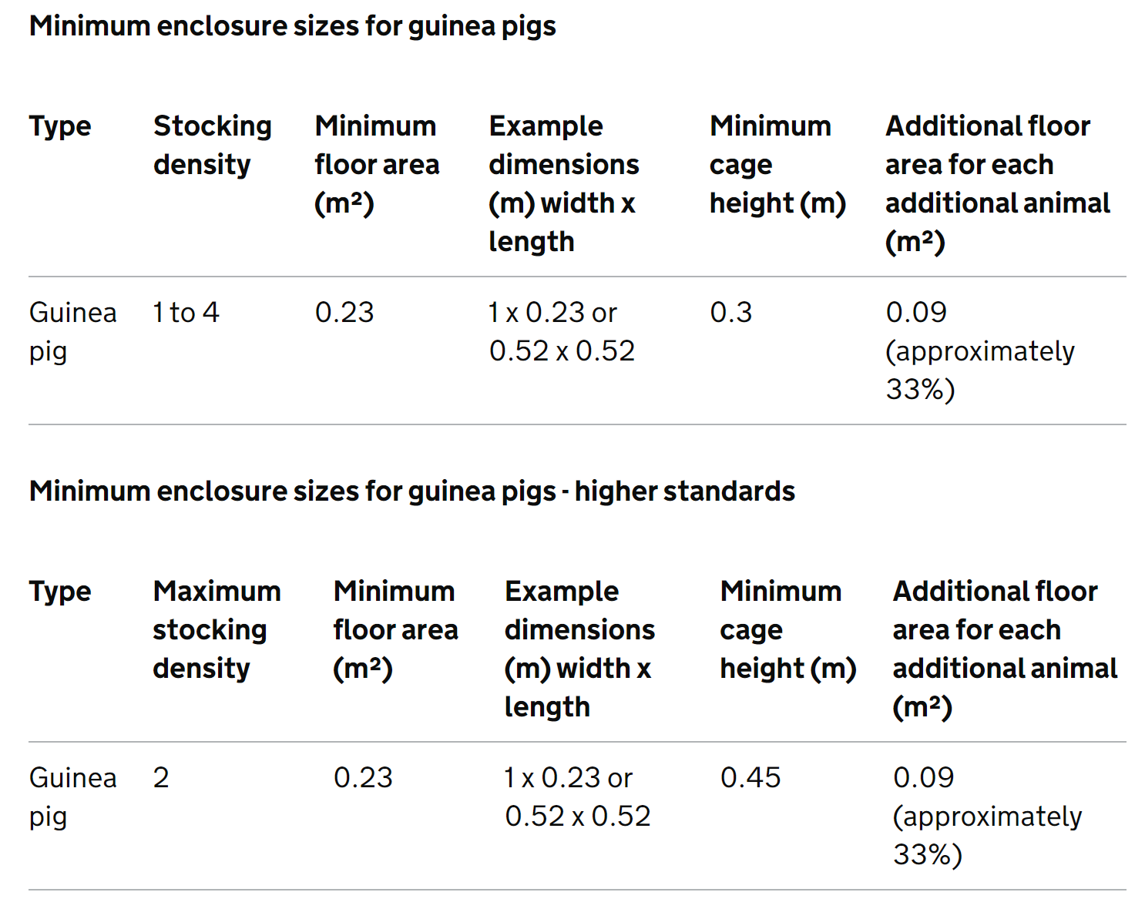

Transporting and handling guinea pigs

Guinea pigs are only to be transported in suitable carriers and must not be mixed with unfamiliar animals in the same carrier. The carrier must be of an appropriate size so that it is not overcrowded.

Housing and competition of guinea pigs

There must be sufficient cover for each guinea pig housed within an enclosure and there must be 2 entrance or exit points to prevent monopolisation.

Required higher standards for providing a suitable environment for guinea pigs

- Where guinea pigs are housed, they must have permanent attached access to a secure pen.

- See the minimum enclosure sizes that must be followed.

Required higher standards for transporting and handling guinea pigs

- Carriers must open from the top to facilitate removal of the animal. Carriers must be lined with newspaper or bedding to absorb urine

How do you meet this standard?

Inspectors comments –

6.0 Suitable diet for guinea pigs
All guinea pigs must be fed a suitable diet primarily consisting of a constant supply of ad lib fresh hay. Hay needs to be free from contamination.

Guinea pigs must have sufficient vitamin C in their diet as they are unable to synthesise this specific vitamin. Therefore, a portion of specific guinea pig food must be given daily or alternatively, a stabilised vitamin C commercially available supplement can be provided.

Care must be taken in product selection and suitability and if in doubt the vet must be consulted.

Guinea pigs can also be given a portion of washed leafy green vegetables daily.

Commercially available guinea pig foods can be given to supplement the primary diet of hay. A balanced and adequate nutrient intake should be ensured. Selective feeding should be considered and mitigated by staff. Food must be appropriate to the age and breed of the guinea pig and manufacturer’s feeding guidelines must be followed.

Water may be provided in a clean gravity fill drinking bottle (which must be of a suitable size for the individual), automatic drinkers, or in bowls.

Any changes to drinking receptacles must be made gradually and drinking monitored to ensure animals are drinking normally.

Monitoring guinea pig diet

A vet must be consulted if there is no improvement where a guinea pig has mild anorexia or reduced appetite within 12 hours of onset or the condition of the individual deteriorates.

A vet must be consulted promptly if guinea pigs show signs of ill health.

Required higher standards for guinea pigs’ diet

- Forage foods (that have been collected in uncontaminated areas and correctly identified) must be fed to the guinea pigs. Commercially available dried forages including willow can also be used to supplement the diet and provide a low risk alternative to foraged foods.

Optional higher standards for guinea pigs’ diet

- Guinea pigs must be provided with access to growing grass to graze on. This can be achieved by placing planted grass trays in their exercise areas. There must be enough grass for all guinea pigs housed to graze simultaneously. Alternatively, guinea pigs can be provided with fresh vegetables high in vitamin C every day.

How do you meet this standard?

Inspectors comments –

7.0 Monitoring rabbits’ behaviour and training
Suitable enrichment items include, but are not limited to, tunnels, paper bags filled with hay, willow sticks and balls, and branches from non-toxic untreated fruit trees (such as apple).

Required higher standards for monitoring rabbits’ behaviour and training

- Dietary enrichment must be used. For example, nuggets can be scattered around the enclosure, fed in puzzle feeders or hidden in paper bags or cardboard tubes. Where puzzle feeders or dispensers are used, guinea pigs must be monitored to ensure they can access the food.

How do you meet this standard?

Inspectors comments –

8.0 Handling and interactions with guinea pigs
Guinea pigs are not to be placed on their back in positions of tonic immobility, nor must they be picked up by the scruff of their neck. Two hands must be used to support larger or adult guinea pigs.

Interactions with guinea pigs
Guinea pigs must be housed in single sex groups unless sold or used for breeding.

Guinea pigs and rabbits must not share the same housing.

Required higher standards for interactions with guinea pigs

- Where guinea pigs have to be housed singly they must be provided with extra sources of enrichment. A plan must be in place for singly housed guinea pigs.

How do you meet this standard?

Inspectors comments –

9.0 Protecting guinea pigs from pain, suffering injury and disease
Guinea pigs front teeth and nails must be checked regularly, unless inappropriate at the stage of the breeding cycle, and treated as necessary, to ensure they are not overgrown or misaligned - only a vet may correct overgrown or misaligned teeth. Guinea pigs in breeding harems must be checked as appropriate based on the management system.

How do you meet this standard?

Inspectors comments –

Inspectors check list to award the Higher Standard

100% of the required higher standard and at least 50% of the optional higher standard are required.

Required higher standards for providing a suitable environment for guinea pigs

- Where guinea pigs are housed, they must have permanent attached access to a secure pen.

- See the minimum enclosure sizes that must be followed.

Required higher standards for transporting and handling guinea pigs

- Carriers must open from the top to facilitate removal of the animal. Carriers must be lined with newspaper or bedding to absorb urine

Required higher standards for guinea pigs’ diet

- Forage foods (that have been collected in uncontaminated areas and correctly identified) must be fed to the guinea pigs. Commercially available dried forages including willow can also be used to supplement the diet and provide a low risk alternative to foraged foods.

Required higher standards for monitoring rabbits’ behaviour and training

- Dietary enrichment must be used. For example, nuggets can be scattered around the enclosure, fed in puzzle feeders or hidden in paper bags or cardboard tubes. Where puzzle feeders or dispensers are used, guinea pigs must be monitored to ensure they can access the food.

Required higher standards for interactions with guinea pigs

- Where guinea pigs have to be housed singly they must be provided with extra sources of enrichment. A plan must be in place for singly housed guinea pigs.
Optional higher standards for guinea pigs’ diet

- Guinea pigs must be provided with access to growing grass to graze on. This can be achieved by placing planted grass trays in their exercise areas. There must be enough grass for all guinea pigs housed to graze simultaneously. Alternatively, guinea pigs can be provided with fresh vegetables high in vitamin C every day.
Has the higher standard been achieved? Yes/No

Inspectors additional comments:

Inspectors Name: Date of inspection:

First payment received: £ Received by:

