Part H – Selling small domestic rodents
Domestic small rodents means hamsters, rats, mice, chinchilla, degus

5.0 Suitable environment
Businesses must prevent the risk of injury, illness and escape.

If wire cages are used, bars must be narrow enough to avoid the risk of escape.

Slatted, grid or wire mesh floors are not to be used in small animal housing. Chinchillas can be housed in cages with wire mesh floors if there are areas of alternative flooring such as solid wood.

See the minimum enclosure sizes that must be followed.

Environmental conditions, including enclosure sizes for small rodents

Every animal must be able to lie fully outstretched, turn around unimpeded, stand fully upright without touching the cage roof, hide, dig, run and play.

Sleeping areas need to be dry, draught-free, well ventilated and clean as well as large enough to allow all the small rodents housed to rest together fully outstretched, turn around unimpeded and move around comfortably.

Bedding and substrate for small rodents

Small rodents must be provided with suitable nesting material in sufficient amounts. The type used will depend on the animal kept. Small rodents must not be given nesting materials which can separate into thin strands, for example, cotton wool.

Suitable nesting materials for small rodents include, but are not limited to:

- hamsters - hay, wood wool, shredded paper or cardboard
- rats and mice - hay, shredded paper, paper strips and paper tissues
- gerbils - ink-free cardboard (for example, empty toilet rolls, egg boxes, plain cardboard boxes) or paper and hay
- chinchillas and degus must be provided with constant access to a nest box filled with hay

Any hay, nesting materials and substrates provided must be good quality and dust-free.

Small rodents must be provided with a suitable litter and substrate in sufficient amounts. There are a number of different litters available and the type will depend on the animal kept. Suitable materials include but are not limited to:

- hamsters - dust-free wood shavings or granulated corn-cob
- rats and mice - non-aspen woodchips, cellulose based chips or shredded paper
- gerbils - peat-free compost or rough-grained woodchip or hay mix
- chinchillas - shredded paper, dust-free wood shavings and hay
- degus - dust-free wood shavings and hay

Small rodents must be provided with constant access to places to hide, in addition to their sleeping area. As a minimum each hiding place needs to be large enough to allow one individual to rest alone.

Temperature for small domestic rodents

Temperatures must be appropriate to species specific or life stage consideration. In general ambient temperatures must not go below 12°C or exceed 26°C. This may be provided with nesting material.

High temperatures above 18°C can be detrimental to chinchillas and extra checks and precautions must be made on these in very hot weather.

Providing sufficient nesting material can help achieve these temperatures.

Minimum enclosure sizes for small rodents

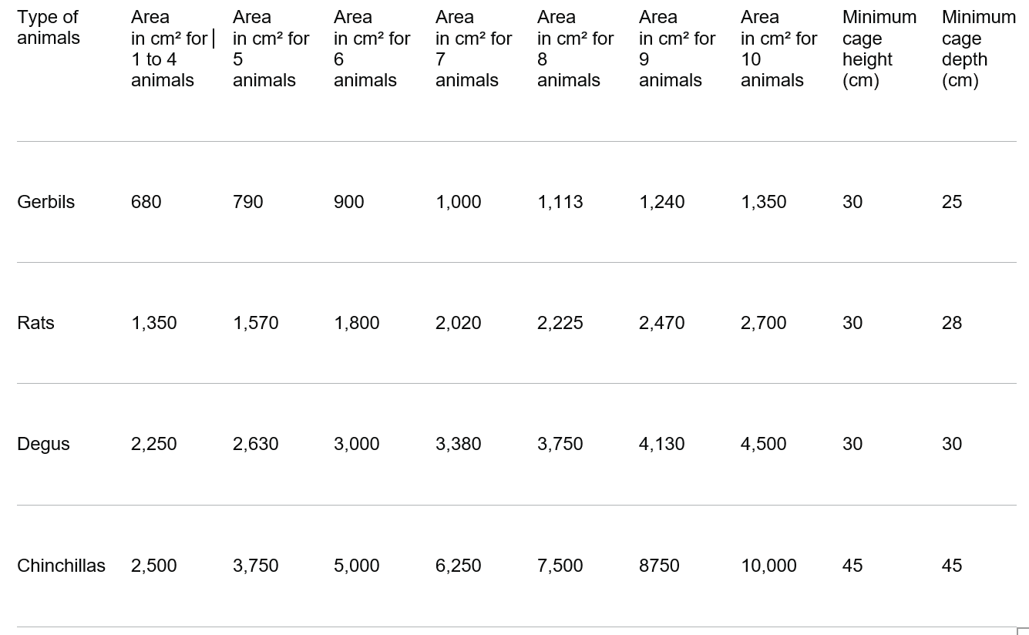

Minimum enclosure sizes for small rodents - higher standards

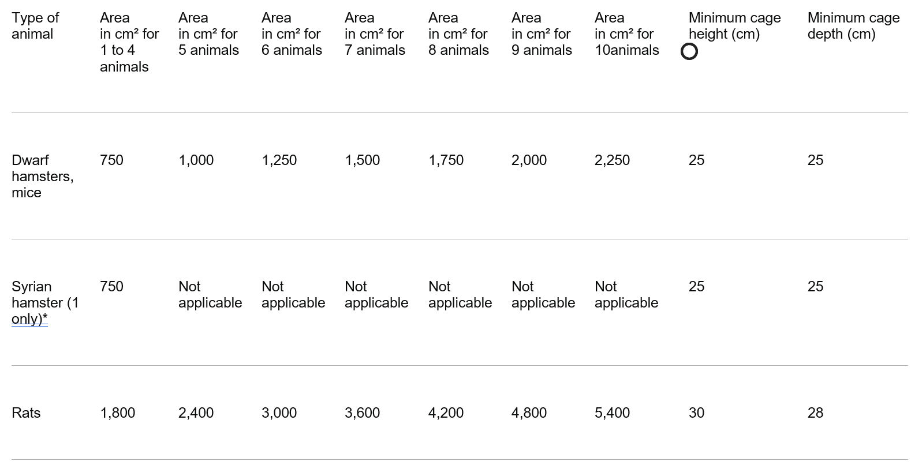
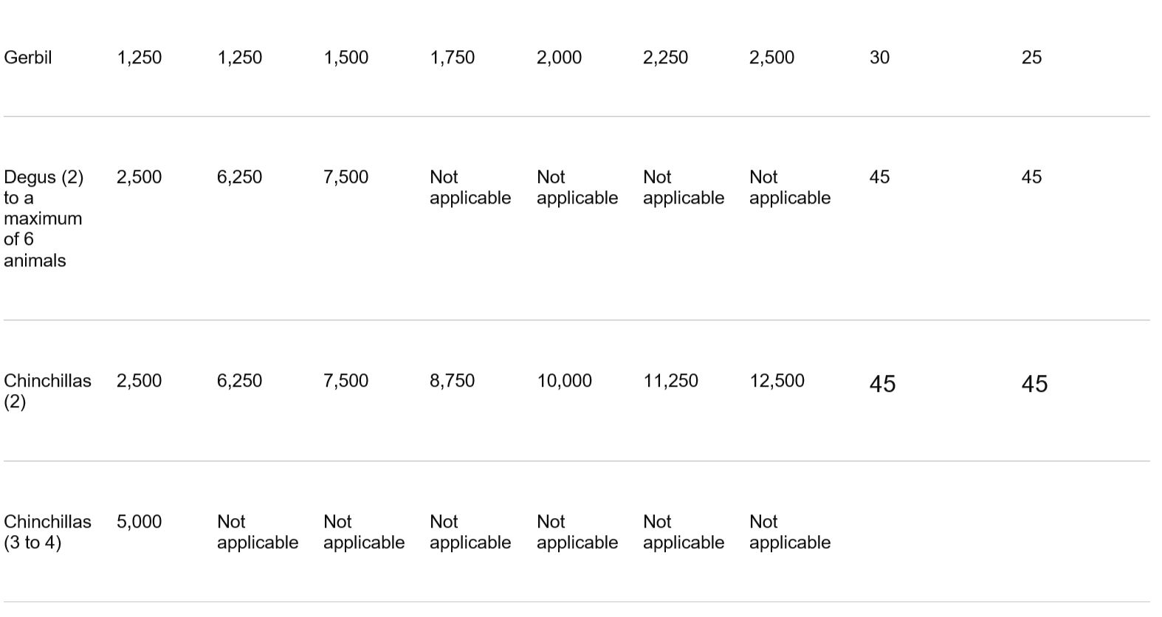
*Syrian hamsters under 12 weeks old are allowed to have the same enclosure size as dwarf hamsters. Once sexually mature, a Syrian hamster must be kept individually.

Handling and transport of small domestic rodents

Small rodents must be transported in suitable carriers and must not be mixed with unfamiliar animals (in the same carrier). They must be transported with their companion small rodents, where applicable, and the carrier is to be of an appropriate size so that it is not overcrowded.

Required higher standards for providing a suitable environment for small rodents

- See the minimum enclosure sizes that must be followed.

- Light-reducing shelters for rats, mice and hamsters (such as, but not limited to, a box or red tinted acrylic) must be provided. However, these must be monitored daily for signs of chewing and removed or replaced as necessary.

- Small rodents must be provided with a choice of different nesting materials.

Required higher standards for cleaning small rodents’ environment

- After cleaning, some used unsoiled litter and nesting material must be transferred back to help keep scents familiar for the rodents.

Optional higher standards for providing a suitable environment for small rodents

- Small rodents that are physically able to use platforms must be provided with access to a platform (singly housed) or multiple platforms. Animals must be able to access these easily and be able to sit (ideally stand) up on it fully without touching the cage roof.

Optional higher standard for small rodents’ light

- When work is occurring near, or nocturnal animals are checked at night, dim red light or dim white light must be used to minimise disturbance. Light level must be sufficient enough for observing or undertaking required tasks.

How do you meet this standard?

Inspectors comments –

6.0 Suitable diet for small domestic rodents
All small rodents must be fed a suitable diet that is available to them at all times.

Chinchillas and degus must have constant access to good quality dust-free hay.

All small rodents must be fully weaned on admission.

Monitoring small rodents’ diet

If there is no improvement in poor intake or not eating within 12 hours or the condition of the individual deteriorates, a vet must be consulted.

A vet must be consulted promptly if a small mammal shows signs of ill health.

Water for small domestic rodents

Water must be provided in a bottle or automatic water systems and located away from the sleeping area to help prevent this becoming damp or waterlogged if the bottle leaks.

How do you meet this standard?

Inspectors comments –

7.0 Monitoring small domestic rodents’ behaviour and training
Enrichment for small domestic rodents

Suitable enrichment items include, but are not limited to, tunnels, paper bags filled with hay, willow sticks or balls and branches from non-toxic, untreated fruit trees (for example, apple). Opportunities for gnawing should always be available.

Chinchillas and Degus must be given the opportunity to use a sand bath by offering one on a regular basis, for example 10 minutes daily. This should not be permanently available.

Small mammals must not be given enrichment made of rubber, due to the risk of ingestion leading to intestinal blockages if chewed and swallowed.

How do you meet this standard?

Inspectors comments –

8.0 Handling and interactions with small domestic rodents
Small rodents must not be picked up by the scruff of their necks, ears or unsupported by the tail, nor must they be placed on their backs in positions of tonic immobility. Picking small mammals up unsupported by the tail can result in their tail breaking or the skin sloughing off (degloving). Additionally, if chinchillas are handled roughly they may shed some of their fur.

Interactions with small domestic rodents

All small rodents must be housed in single sex groups unless a solitary species (or sold or used for breeding).

Small rodents must only be housed with other rodents of the same species.

Required higher standards for handling and interactions with small domestic rodents

- Where social species of small rodents have to be housed singly they must be provided with extra sources of enrichment. A plan must be in place for singly housed small rodents (only those of a social species).

How do you meet this standard?

Inspectors comments –

9.0 Protecting ferrets from pain, suffering injury and disease
The front teeth and nails of every small rodent must be checked monthly, unless inappropriate at the stage of the breeding cycle, to ensure they are not overgrown or misaligned - only a vet may correct overgrown or misaligned teeth. They should have a pre-mating check and then a check at weaning time.

How do you meet this standard?

Inspectors comments –

Inspectors check list to award the Higher Standard

100% of the required higher standard and at least 50% of the optional higher standard are required.

Required higher standards for providing a suitable environment for small rodents

- See the minimum enclosure sizes that must be followed.

- Light-reducing shelters for rats, mice and hamsters (such as, but not limited to, a box or red tinted acrylic) must be provided. However, these must be monitored daily for signs of chewing and removed or replaced as necessary.

- Small rodents must be provided with a choice of different nesting materials.

Required higher standards for cleaning small rodents’ environment

- After cleaning, some used unsoiled litter and nesting material must be transferred back to help keep scents familiar for the rodents.

Required higher standards for handling and interactions with small domestic rodents

- Where social species of small rodents have to be housed singly they must be provided with extra sources of enrichment. A plan must be in place for singly housed small rodents (only those of a social species).

Optional higher standards for providing a suitable environment for small rodents

- Small rodents that are physically able to use platforms must be provided with access to a platform (singly housed) or multiple platforms. Animals must be able to access these easily and be able to sit (ideally stand) up on it fully without touching the cage roof.

Optional higher standard for small rodents’ light

- When work is occurring near, or nocturnal animals are checked at night, dim red light or dim white light must be used to minimise disturbance. Light level must be sufficient enough for observing or undertaking required tasks.

Has the higher standard been achieved? Yes/No

Inspectors additional comments:

Inspectors Name: Date of inspection:

Inspectors signature:

First payment received: £ Received by:

