Part J – Selling birds

3.0 Use, number and type of birds
Staff must have demonstrable knowledge of the species or of a closely related species.

Any doubt or dispute regarding the husbandry of species not specifically detailed below must be referred to an individual with suitable experience of husbandry such as an exotics vet or related professional.

How do you meet this standard?

Inspectors comments –

5.0 Suitable environment for birds
Care must be taken where aviaries or cages are constructed of newly galvanised mesh to prevent heavy metal poisoning, particularly in psittacine birds which will often chew the metal. The licence holder must be able to demonstrate the steps taken to minimise or prevent any poisoning.

Cages or aviaries should be constructed from materials most suited for the species housed and that are easy to clean and disinfect.

Environmental conditions for birds (including enclosure sizes)

All immature arboreal birds, at the point of fledging and for several following weeks, require larger cage sizes to stimulate flight.

Where a bird uses a cage for sleeping, and the vast majority of the day is spent outside of the cage in a flight aviary where it is given the option to fly, then the cage must be a minimum of one and a half times the bird’s flying wingspan for each of the length, depth and height of the cage.

For birds housed singly that spend the majority of their time in a cage, the cage width must be a minimum of twice flying wingspan, and the depth and height a minimum of one and a half times the birds flying wingspan. A pair of birds must have enough space to fly past each other with the depth being increased to a minimum of 2x flying wingspan.

In multiple occupancy cages for every additional bird over 2 birds the cage dimensions must be increased by a set percentage per additional bird (either length or width or split between the 2 dimensions) of the individual’s flying wingspan for that species as outlined in the avian enclosure size increases for multiple occupancy table. Larger sizes are preferred and recommended. See minimum enclosure sizes for birds for examples.

In the case where the flying wingspan is unknown a rough estimate of 2 to 3 times the length of the bird (bill-tip to tip of longest tail feather) can be used as a guide for flying wingspan.

Where non-flying birds are maintained, enclosure dimensions must reflect current best practice for the individual species.

Birds that are ordinarily confined to smaller enclosures for the specific purpose of egg-laying or rearing of chicks (particularly chickens and pigeons) are exempted from the cage size dimensions referenced. However, the time kept in these enclosures should be minimised and should not, in any case, exceed 5 months in any one 12 month cycle. Businesses must also provide outcome based evidence to demonstrate that the welfare of the birds is being met with reference to guidance in the rest of this document, and ensure that they are complying with the legal requirements laid down in other relevant legislation.

Where appropriate for the species outdoor aviaries must include sufficient sheltered and non-sheltered space. Shelter must be sufficient to allow all the birds to be undercover at the same time and preferably a third of a typical aviary should be covered with wind and rain-proof materials.

Where a separate flight aviary is available, the licence holder must be able to demonstrate the frequency with which the birds have access to this larger aviary to the inspector. This must be a demonstrable minimum of 6 hours in a 24 hour period on a daily basis.

The mesh hole size must be small enough that birds housed within cannot put their head or wing through it. The mesh gauge must be stout enough that the birds cannot break or bend it.

As appropriate to species, birds must be given access to water for bathing and preening to encourage feather health.

Birds must not be exposed to toxic or cooking fumes in the areas where they are maintained as these can be toxic to the birds (for example, Teflon poisoning). Aviaries or cages must not be located next to kitchens or bathrooms.

Aviaries should have a covered roof of netting with a mesh size small enough that birds housed within cannot put their head or wings through it or be of solid construction due to the presence of avian influenza in migratory waterfowl.

Bedding and substrate for birds

There must be adequate perching space for all birds at the same time. Perches must be positioned to encourage activity, preferably flight, and so that birds do not defecate on each other or into food receptacles.

Perching must be varied and non-abrasive to prevent bumblefoot.

Suitable substrate should be provided for ground dwelling birds that scratch and forage.

Temperature for birds

Ambient temperature must be appropriate for the species. Extremes of temperature must be avoided.

Light for birds

Lighting levels must approximate those of daylight with regard to intensity and colour.

Species requiring UVB (ultraviolet B) lighting must have appropriate UVB emitting lamps manufactured for use with birds. These must be replaced according to manufacturer’s recommendations, and effective provision must be monitored through the use of a UV (ultraviolet) meter. Evidence to this effect must be demonstrable to inspectors.

Species | Length of bird (head to tip of tail)  (cm) | Average length of flying wingspan  (cm) | Minimum cage dimensions to allow flight (single birds only)* (cm)  (L 2x wingspan, D/H 1.5x wingspan) |  |  | Examples for  % enclosure size increase for each additional bird  >2 birds
 |  |  | L | D | H
Psittacines
Budgerigar | 18 | 30 | 60 | 45 | 45 | 5
Cockatiel | 30 | 48 | 96 | 72 | 72 | 10
Love bird | 15 | 28 | 56 | 42 | 42 | 10
Small parakeets and conures | 20 | 35 | 70 | 52.5 | 52.5 | 10
Large parakeets, conures and small macaws | 34 | 70 | 140 | 105 | 105 | 20
Amazon parrots | 30 | 60 | 120 | 90 | 90 | 20
African grey (inc Timneh) | 34 | 70 | 140 | 105 | 105 | 20
Cockatoo (small - medium) | 35 | 75 | 150 | 112.5 | 112.5 | 20
Large cockatoos and macaws | 85 | 110 | 220 | 165 | 165 | 20
Cage and aviary birds
Canary | 10 -12 | 22 | 44 | 33 | 33 | 5
Zebra finch | 10 -12 | 22 | 44 | 33 | 33 | 5
Pigeon | 35 | 70 | 140 | 105 | 105 | 10
Turaco | 40-50 | 50 | 100 | 75 | 75 | 20

For multi-occupancy cages, the dimensions must be a minimum of 2 flying wingspans for length, height and depth, with stocking allowing all birds access to resources, particularly perching.

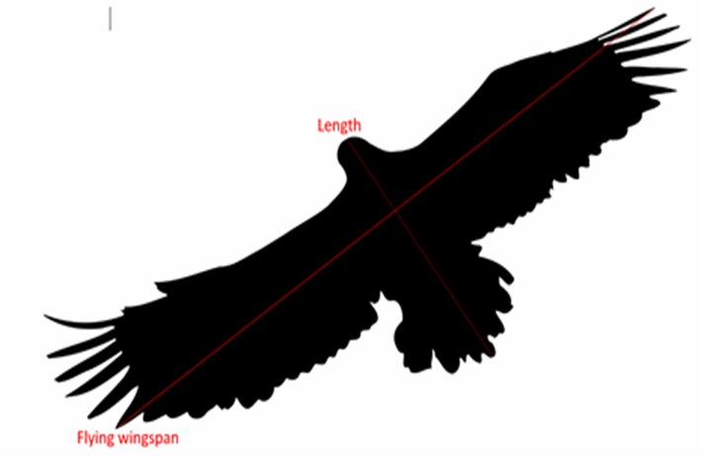

Avian enclosure size increases for multiple occupancy

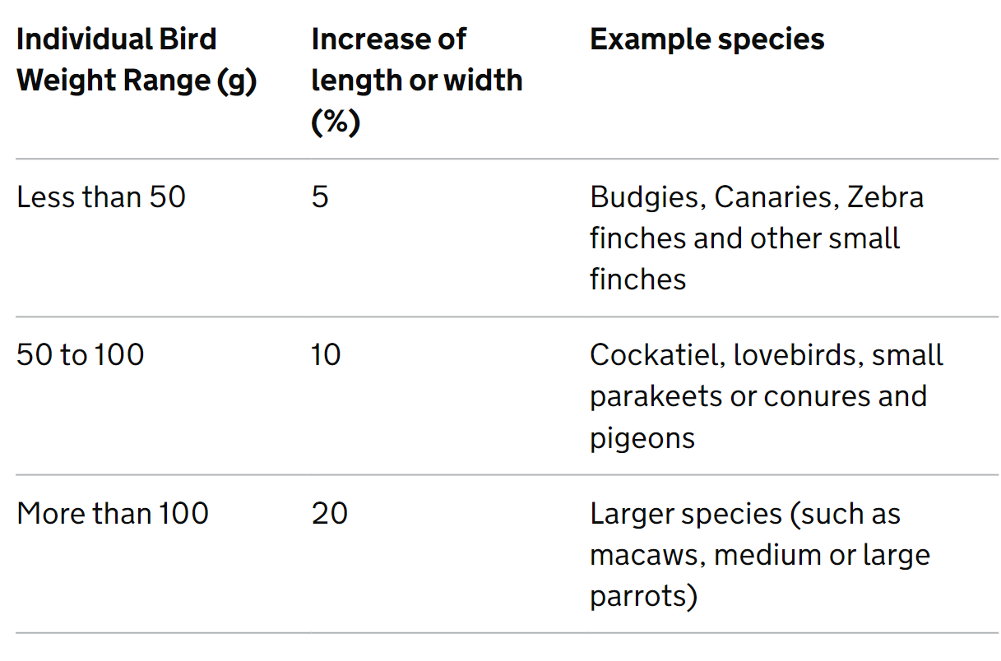

Additional increase per number of birds over 2 birds. For example, 3 birds that weigh less than 50 grams equals a 5% increase, for every additional bird the increase will be an additional 5%.

Cleaning birds

Faeces and urates must be removed at least once a week, but more frequently as required. For species which are in poor health or should not be disturbed during breeding seasons, cleaning should be minimalized, provided that appropriately hygienic living conditions are maintained.

Containers for food and water should not be placed below perches, where they can be contaminated by birds’ droppings.

Flooring must be drop-through or easily cleaned, with consideration of selection of substrate type and minimal disturbance for ground dwelling birds.

Required higher standards for providing a suitable environment for birds

- The enclosure size must allow the bird to have variety and choice in its environment.

- Birds must be displayed for sale in aviaries that are 4 times the bird’s flying wingspan or larger in size for length, depth and height for an individual bird and 20% increase for each successive bird for multiple occupancy.

- A variety of substrates, including a variety of perches for arboreal birds must be provided. Perches of a variable thickness and materials must be provided.

- Output of UVB bulbs must be monitored with a UV meter and recorded. Species specific requirements must be documented and available for inspection.

Optional higher standard for providing a suitable environment for birds

- All cages must have direct access to a flight aviary.

How do you meet this standard?

Inspectors comments –

6.0 Suitable diet for birds
Birds that require it must have a constant ad lib supply of food.

Food supplements must be provided as appropriate to the species concerned.

Specialist feeding practices must be taken into consideration in aviary design, such as access for breeding aviaries or flycatcher manure piles. At times these may be in perceived conflict with expectations for hygiene and where in doubt specialist advice must be sought. Licence holders must be able to demonstrate the rationale behind any specialist feeding practices being utilised.

Required higher standard for birds’ diet

- Specialist nutritional advice must be sought where appropriate.

How do you meet this standard?

Inspectors comments –

7.0 Monitoring birds’ behaviour and training
Enrichment

Enclosures must be designed, furnished and of a size which allows inhabitants to exhibit a range of natural behaviours, including flying, climbing and hiding.

Psittaciformes, and other species as appropriate, must be provided with suitable toys which encourage them to play and to ‘forage’ for foods.

Cages and aviaries must have at least one side (one of its horizontal dimensions) clad in an opaque material, so that the occupants are not vulnerable on all sides to viewing and disturbance.

Birds of prey subject to restraint by tethering for part of their lives must be flown at least 4 times a week unless tethered under veterinary advice for medical treatment. Licence holders must not permanently tether any bird. All birds must be given the opportunity to fly or move around freely during part of the year, for example in an aviary (free lofted) for rest periods from sale, demonstrations, breeding or moulting. The recommended period is a minimum of one month in a 12 month period but daily or overnight is preferred.

Habituation of birds

Handling must be kept to a minimum at all times except where the licence holder can demonstrate that it is for a reason that is in the best interest of the animal, for example to check the birds’ health checking, flying birds of prey.

Required higher standards for monitoring birds’ behaviour

- Birds must not be housed or sold with their wings clipped. Wings are kept complete and flight is actively encouraged.

- All birds of prey, or other trained birds where appropriate, must have daily periods of flight; either in aviaries or flown outdoors by a competent person.

Optional higher standard for monitoring birds’ behaviour

- Furniture must be changed on a regular basis to provide novelty and enclosures designed to provide choice for the animals within.

How do you meet this standard?

Inspectors comments –

8.0 Handling and interactions with birds
Social species must be kept in social groups suitable to the species. Where this is not possible, special attention must be paid to specific human interaction and they must be provided with extra enrichment. A plan must be in place for all singly housed birds.

Decisions to pair or group-house social bird species must be made by suitably trained and competent staff.

Compatible species-specific sex ratios and suitable group sizes must be observed bearing in mind potential for persistent aggression.

Only compatible species must be kept communally.

In particular, consideration for management of psittacine species, known to be sociable and live in flock situations, must be shown in the housing arrangements and stocking densities.

All immature birds must be housed with, or housed in close proximity to, others of their own or similar species, using adjacent cages or aviaries where they are in visual contact.

Where behavioural problems are likely to arise in ‘adult’ non-colonial birds, consideration must be given to managing them separately with the same species adjacent in visual contact. Examples of species that breed in a group include budgerigars and cockatiels, non-colonial breeders include African greys, Amazons and cockatoos. Once non-colonially nesting species approach breeding age, keeping 2 or more in a cage can be dangerous, as paired birds of breeding age can be aggressive to each other and their own mate.

Required higher standards for handing and interactions with birds

- Birds must not be removed from their parents (for ‘hand rearing’) until their eyes have been opened for more than one week to avoid risk of mal imprinting on humans as adult birds.

- Adult non-colonial birds must be managed in large flights, to allow birds space to escape from each other if required to prevent behavioural problems. Sufficient staff to manage the population must be provided as needed.

Optional higher standard for handing and interactions with birds

- The licence holder must have signage identifying potentially aggressive birds including clearly labelled aviaries and cages.

How do you meet this standard?

Inspectors comments –

Inspectors check list to award the Higher Standard

100% of the required higher standard and at least 50% of the optional higher standard are required.

Required higher standards for providing a suitable environment for birds

- The enclosure size must allow the bird to have variety and choice in its environment.

- Birds must be displayed for sale in aviaries that are 4 times the bird’s flying wingspan or larger in size for length, depth and height for an individual bird and 20% increase for each successive bird for multiple occupancy.

- A variety of substrates, including a variety of perches for arboreal birds must be provided. Perches of a variable thickness and materials must be provided.

- Output of UVB bulbs must be monitored with a UV meter and recorded. Species specific requirements must be documented and available for inspection.

Required higher standard for birds’ diet

- Specialist nutritional advice must be sought where appropriate.

Required higher standards for monitoring birds’ behaviour

- Birds must not be housed or sold with their wings clipped. Wings are kept complete and flight is actively encouraged.

- All birds of prey, or other trained birds where appropriate, must have daily periods of flight; either in aviaries or flown outdoors by a competent person.
Required higher standards for handing and interactions with birds

- Birds must not be removed from their parents (for ‘hand rearing’) until their eyes have been opened for more than one week to avoid risk of mal imprinting on humans as adult birds.

- Adult non-colonial birds must be managed in large flights, to allow birds space to escape from each other if required to prevent behavioural problems. Sufficient staff to manage the population must be provided as needed.

Optional higher standard for providing a suitable environment for birds

- All cages must have direct access to a flight aviary.

Optional higher standard for monitoring birds’ behaviour

- Furniture must be changed on a regular basis to provide novelty and enclosures designed to provide choice for the animals within.

Optional higher standard for handing and interactions with birds

- The licence holder must have signage identifying potentially aggressive birds including clearly labelled aviaries and cages.

Has the higher standard been achieved? Yes/No

Inspectors additional comments:

Inspectors Name: Date of inspection:

Inspectors signature:

First payment received: £ Received by:

