Part K – Selling reptiles and amphibians

3.0 Use, number and type of animal
Staff must have demonstrable knowledge of the species or a closely related species.

How do you meet this standard?

Inspectors comments –

5.0 Suitable environment for reptiles and amphibians
Protecting reptiles and amphibians from injury, illness or escape

Vivaria must allow for ease of cleaning and the maintenance of hygienic standards. This includes the use of waterproof materials for construction.

Venomous animals must be kept in appropriate, secure enclosures (with suitable means of escape-proof ventilation).

Service areas for venomous species must be secure. Service areas must be free of escape routes or places to hide, for example access into cavity walls.

Enclosures containing venomous species must be individually marked with warning signs identifying the species and number of animals.

Venomous animal enclosures must be kept locked and access available only by authorised persons.

Environmental conditions (including enclosure sizes for reptiles and amphibians)

See the minimum enclosure sizes that must be followed.

The size of the vivarium must allow a demonstrable and species-appropriate thermogradient to be maintained.

All vivaria must be provided with hides or species appropriate areas of shelter.

The vivarium must be large enough to allow the animals separate types of activity including:

- resting
- thermo-regulating
- feeding
- hiding
- swimming (if applicable)

Only compatible species of similar size and from similar habitat and geographical areas must be kept communally.

Cannibalistic species should not be kept communally.

Predator and prey species should not be kept in sight of each other. Where possible, they should be in different areas to minimise stress due to smell or noise.

Aggressive individuals such as breeding males should be kept singly, or in conditions to suppress aggression.

Generally, mixing of species requiring different environmental conditions is not recommended. Although paludaria (vivaria with terrestrial and aquatic areas) which combine fish with small reptiles or amphibians of appropriate species are acceptable.

Reptiles and amphibians may be housed individually or in small groups of the same or compatible species.

Aquatic species must be able to swim (or submerge) adequately and should have a water depth suitable for the species and life stage.

To prevent trauma, materials with rough surfaces (such as metal mesh) must be used with caution in the construction of vivaria, unless there are species-specific requirements that indicate their use (for example, those requiring high ventilation rates). Where possible, plastic or other suitable alternative materials are preferred.

For reptile species or life stages where evidence suggests that smaller spaces are required for feeding or security, the animal must be maintained in the size-appropriate vivarium (as defined below). This is with the addition of a number of small hides, ensuring the animal has the choice to move out into the wider vivarium at any time and enable appropriate thermoregulation whilst ensuring the reptile feels secure. Where there are documented problems with feeding individual reptiles in larger spaces they may be maintained in smaller enclosures.

Bedding and substrate for reptiles and amphibians

Substrate may include, but not be limited to:

- paper towel
- bark chip
- wood chip
- terrarium humus
- moss
- gravel
- terrarium sand

Suitable substrate must be chosen depending on the species.

Burrowing species must have an appropriate substrate to facilitate burrowing.

Measures must be taken to minimise ingestion of substrate.

A moisture gradient is recommended for many amphibians. In setups which are misted on a regular basis to keep humidity levels elevated, it is important that a drainage layer is provided in the enclosure to avoid the substrate from becoming waterlogged. Drainage must be considered in all setups where there is a risk of waterlogging.

Temperature for reptiles and amphibians

Licence holders must be able to demonstrate that enclosures provide an appropriate thermogradient (the temperature range from the cool end to the hot end of the vivaria) for each species.

Temperature must be monitored using a reliable and repeatable method. Licence holders must be able to demonstrate systems are in place to allow assessment of the range of temperatures an animal experiences over a 24 hour period, this can be done using a maximum and minimum thermometer, for example.

Temperature must be checked daily on initial setup of a vivarium. Once the temperatures are stable, where thermostatically controlled heat sources are used, assessment can be reduced to once per week. Alternatively, an automatic system can be used that monitors temperatures and warns if parameters are outside of an acceptable range.

Records should be kept of instances where parameters fall outside of the appropriate range and what corrective actions were taken. There is no requirement to record ongoing conditions that fall within the appropriate range.

Appropriate temperatures for each species that is in stock or commonly stocked by the licence holder must be documented in written procedures.

At a minimum, the written procedures must document:

- ambient day temperature range
- minimum ambient night temperature
- basking zone temperature (where appropriate)
- UV requirements (where appropriate)

Where clearly defined ambient and basking temperatures are not available for a species, comparable species from a similar geographical habitat can be used to define the range. For such species where there are no known care guidelines and specialist husbandry is required, these species must only be sold to competent specialist keepers.

Any deviations from the expected temperature range must be recorded along with the action taken to ensure the appropriate temperature is provided for the animal.

Heating equipment must be controlled with the use of thermostats where compatible, and the vivaria sited so as to prevent overheating.

Where rack systems or other vivaria are utilised in thermally stable heated rooms, temperature monitoring of one tray per level is acceptable. It must be accompanied by spot checks that demonstrate that the recorded temperatures are representative of the other rack systems in the shared space, and that temperatures are maintained at the correct ranges for the species housed within. During inspection, licence holders must be able to demonstrate that this is the case.

Ambient and basking temperatures must be appropriate to the species concerned.

Licence holders and staff must have access to relevant credible reference material for normal environmental parameters.

Basking zones may be provided by radiant heat sources (such as a light bulb or heat mat), as appropriate to the species.

Heat sources for both terrestrial and aquatic species must be guarded or positioned, so no animal living in the enclosure can make direct contact with the heating element. This includes heat-emitting light sources but excludes heat mats and hot rocks or similar such heating devices.

Hides or shelters must be provided in different areas across the thermogradient.

Water quality for reptiles and amphibians

Aquatic amphibians must have water quality measurement similar to that for fish, with species specific requirements being met.

Water for aquatic species of amphibians must be dechlorinated. Methods include harvested rain water (where appropriate) or using commercial dechlorinating products.

Containers must be thoroughly washed between each use.

For semi-aquatic and aquatic reptilian species (such as terrapins, turtles, and crocodilians) and species where water features form a part of the enclosure design, water must be maintained in a clean hygienic state.

Where appropriate, terrapins must also have an adequate land basking area suitable for the species.

Light for reptiles and amphibians

Species requiring UVB lighting must have appropriate UVB emitting lamps manufactured for use with reptiles and amphibians. Replacement equipment, parts or bulbs must be fitted according to manufacturer’s recommendations. On installation of a new lamp, a UV meter (preferably a UVI meter) must be used to ensure adequate and appropriate UVB levels are provided at the level the animal is located. Evidence of the frequency of lamp changes and assessment of UVB output on installation must be demonstrable to inspectors.

UV light sources must not be screened by non-UV transmitting glass, mesh or plastic such that the animals do not receive the appropriate UVB levels. Animals must have areas of shade so that they can escape from the light if desired.

Minimum enclosure sizes for reptiles and amphibians

The snout-to-vent length (SVL) is the distance from the nose to the cloaca.

The snout-to-tail length (STL) is the distance from the nose to the tip of the tail.

The straight-carapace-length (SCL) is the straight length of the curved part of the shell of a tortoise. Carapace is the curved top part of the tortoise or terrapin shell, as opposed to the flat bottom part which is the plastron length (PL).

Height and width of the enclosure must be appropriate to the species. Arboreal species require more height than terrestrial species, and the recommendations stipulated below, must be adjusted accordingly. When considering vivarium size for arboreal species the licence holder must increase the height to the sizes outlined below for length and can reduce the length of the vivarium dimensions by one third.

The following vivarium size guidelines are for a single reptile or amphibian, up to a maximum of 4 animals for group managed species unless specifically stated. For 5 to 8 animals the enclosure sizes area must double and for 9 to 12 triple, and so on.

Most amphibians and reptiles are not social and may therefore be kept individually. Decisions to pair or group-house amphibian or reptile species must be made by suitably trained and competent staff. Compatible species-specific sex ratios and suitable group sizes must be observed bearing in mind potential for persistent aggression.

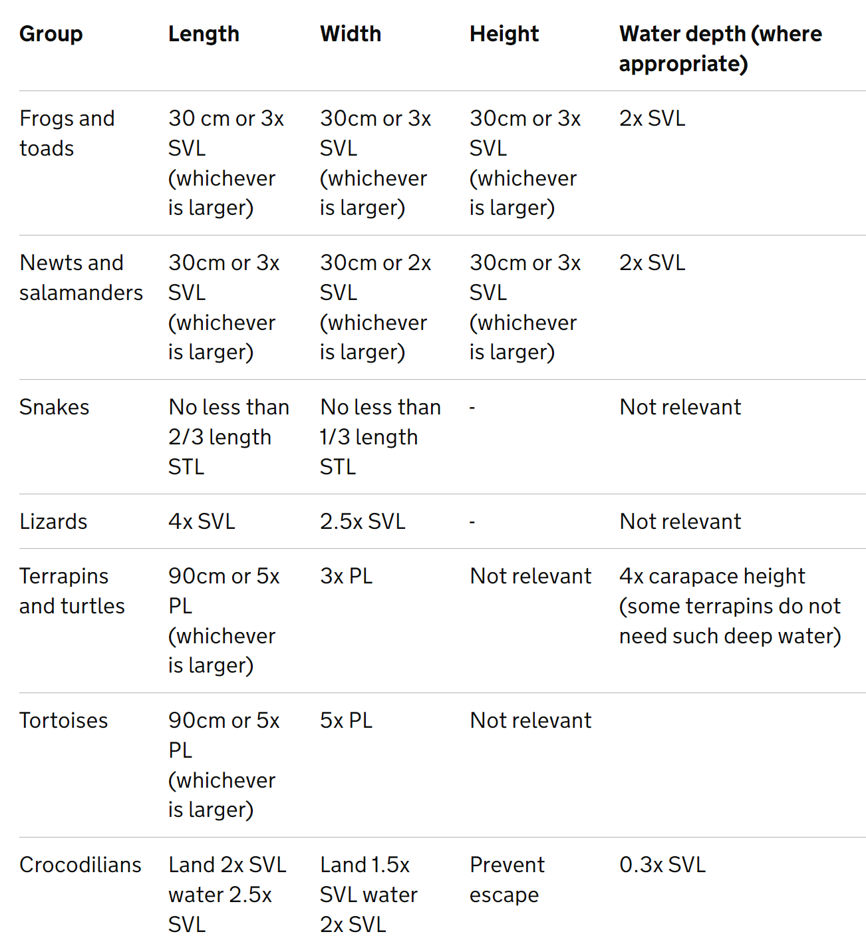

Arboreal species require more height than terrestrial species and sizes, and must be adjusted accordingly.

Vivarium height for arboreal species must increase to the length outlined above. The length of the vivarium can be reduced by one third.

Cleaning for reptiles and amphibians

Faeces and urates must be removed a minimum of once daily if present. An exception to this is a system involving a larger enclosure with small species that has a mature bioactive system of management.

There must be a programme of wastewater management and treatment for all amphibians to ensure no microorganisms are accidentally released. Those selling amphibians must treat wastewater to prevent the spread of chytridiomycosis (fungus) and other viral agents prior to disposal into the sewage. The treatment chosen must be effective against the potential pathogens concerned (for example, sodium hypochlorite, more than 1% for one minute). Evidence as to how this is achieved must be available to inspectors.

Required higher standards for providing a suitable environment for reptiles and amphibians

- The output of UVB lamps must be monitored with a UV meter and recorded on a weekly basis. Species specific requirements must be documented and available for inspection.

- Specific written protocols for the quarantine or prevention of release of chytridiomycosis and potentially other biological agents must be available for inspection where amphibians are maintained.

- For thermostatically stable vivaria, temperature assessment must be increased to 3 times weekly to document maximum and minimum temperatures.

- Where applicable, a minimum of 2 hides or sheltered areas must be provided and located in different areas of the thermogradient.

Optional higher standards for providing a suitable environment for reptiles and amphibians

- Large established or permanent reptilian vivaria with water features must have water filtration systems to ensure hygiene is maintained.

- For species that require brumation, designated facilities must be available and a related policy regarding temperature and other husbandry requirements available for inspection.

- Suitable thermogradient, humidity and UVB index (where applicable) for the species must be displayed on each vivarium.

- Sizing of vivaria and associated environmental parameters must meet or exceed those outlined in the higher standards.

Minimum enclosure sizes for reptiles and amphibians - higher standards

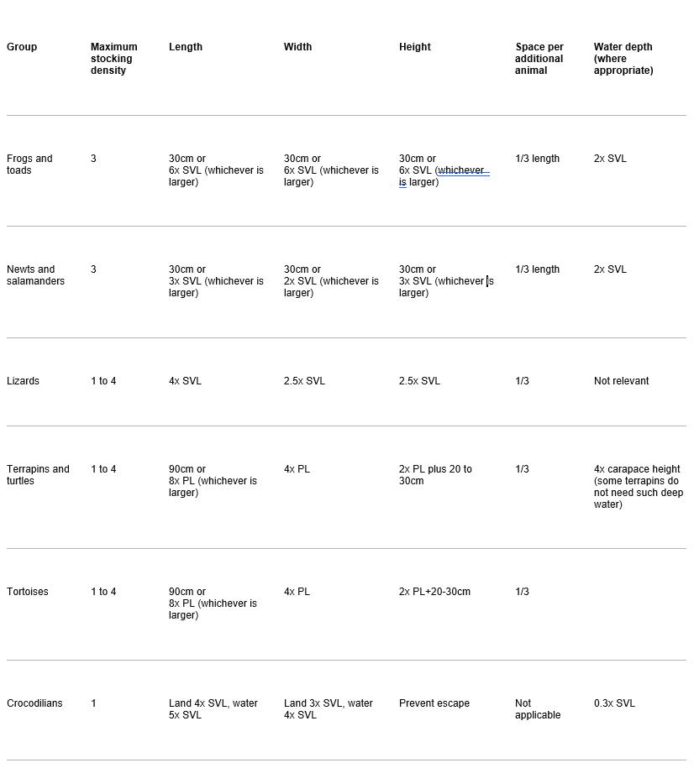

Arboreal species require more height than terrestrial species and sizes, and must be adjusted accordingly.

Vivarium height for arboreal species must increase to the length outlined above. The length of the vivarium can be reduced by one third.

How do you meet this standard?

Inspectors comments –

6.0 Suitable diet for reptiles and amphibians
Diet for reptiles and amphibians

Live invertebrates must be gut loaded or dusted with a suitable vitamin or mineral mix used according to the manufacturer’s instructions and with regard to the specific needs of the animal.

Feeding reptiles and amphibians

Licence holders must maintain written records of feeding for all snakes, including hatchlings, which must be made available to buyers and inspectors.

In situations where a specific reptile species is known to prefer to have food left in for 24 hours, this practice is considered acceptable but must be reflected in the individual species’ care sheet.

Water for reptiles and amphibians

Fresh water must be available at all times with the exception of certain desert species, which must be offered water at a frequency suitable to the species.

As appropriate to species, amphibians and reptiles must be given access to water in a form that allows them to submerge or bathe within.

Certain species, such as chameleons and some amphibians, do not often drink from standing water and must be offered water appropriately using an appropriate method, such as a dripper system or sprayer.

How do you meet this standard?

Inspectors comments –

7.0 Monitoring of behaviour and training for reptiles and amphibians
Enrichment for reptiles and amphibians

Enclosures must be furnished in such a fashion as to allow inhabitants to exhibit natural behaviour, like climb or hide.

All vivaria must be provided with hides or species appropriate areas of shelter.

Habituation of reptiles and amphibians

Handling must be kept to a minimum at all times except where the licence holder can demonstrate that it is in the best interest of the animal, like to habituate the animal to handling for the purpose of health-checking. Beneficial and positive contact depends on species and can include feeding and training.

How do you meet this standard?

Inspectors comments –

8.0 Reptiles and amphibians handling and interactions with birds
For amphibians, water of quality similar to that used to house them must be used for hand washing prior to handling to prevent damage to species with moist skin. Hands must be clean and wet.

Optional higher standard for reptiles and amphibians handling and interactions

- Moist, non-powdered nitrile gloves (or similar) must be used to handle amphibians.

How do you meet this standard?

Inspectors comments –

9.0 Protecting reptiles and amphibians from pain, suffering, injury and disease
A dedicated area for storage of cadavers must be present separate from food stores.

Required higher standard for isolating or quarantining reptiles and amphibians

- A dedicated area of isolation or quarantine must be available with associated protocols and policies in place to ensure biosecurity of the premises.

How do you meet this standard?

Inspectors comments –

Inspectors check list to award the Higher Standard

100% of the required higher standard and at least 50% of the optional higher standard are required.

Required higher standards for providing a suitable environment for reptiles and amphibians

- The output of UVB lamps must be monitored with a UV meter and recorded on a weekly basis. Species specific requirements must be documented and available for inspection.

- Specific written protocols for the quarantine or prevention of release of chytridiomycosis and potentially other biological agents must be available for inspection where amphibians are maintained.

- For thermostatically stable vivaria, temperature assessment must be increased to 3 times weekly to document maximum and minimum temperatures.

- Where applicable, a minimum of 2 hides or sheltered areas must be provided and located in different areas of the thermogradient.

Required higher standard for isolating or quarantining reptiles and amphibians

- A dedicated area of isolation or quarantine must be available with associated protocols and policies in place to ensure biosecurity of the premises.

Optional higher standards for providing a suitable environment for reptiles and amphibians

- Large established or permanent reptilian vivaria with water features must have water filtration systems to ensure hygiene is maintained.

- For species that require brumation, designated facilities must be available and a related policy regarding temperature and other husbandry requirements available for inspection.

- Suitable thermogradient, humidity and UVB index (where applicable) for the species must be displayed on each vivarium.

- Sizing of vivaria and associated environmental parameters must meet or exceed those outlined in the higher standards.

Optional higher standard for reptiles and amphibians handling and interactions
- Moist, non-powdered nitrile gloves (or similar) must be used to handle amphibians.

Has the higher standard been achieved? Yes/No

Inspectors additional comments:

Inspectors Name: Date of inspection:

Inspectors signature:

First payment received: £ Received by:

