Part K – Selling fish
‘Coldwater species’ refers to freshwater ornamental fish species which are kept in unheated aquaria, vats or ponds.

These include, but are not limited to:

- goldfish (all varieties)
- common carp (including Koi)
- tench
- orfe
- rudd
- sturgeon

‘Tropical freshwater’ refers to all those freshwater ornamental fish species that must be kept in heated aquaria.

‘Tropical Marine’ refers to all those ornamental fish species that must be kept in sea water and heated aquaria.

‘Temperate’ refers to those species that are suitable for unheated aquaria kept in centrally heated rooms only.

‘Centralised systems’ refers to multiple aquaria or vats which are connected via pipework to a central sump tank and filter. Water is circulated through the system, so that no water travels directly from one aquaria or vat to another. It instead travels via a biological filter and (possibly) other devices such as UV or ozone. Water quality in such systems is wholly dependent on the management of the whole system.

‘Standalone system’ refers to aquaria or vats which do not share water with others. Filtration (and heating) is provided individually to each aquarium or vat. Water quality in such systems is wholly dependent on the management of each individual aquarium or vat.

3.0 Use, number and type of fish
There are more than 4,000 species of fish in trade whose welfare needs can be met based on a broad categorisation. It is not considered necessary nor feasible to individually identify all fish held within a facility.

It is acceptable for fish to be categorised in broad groupings of:

- cold water
- tropical marine
- tropical freshwater

The maintenance of water quality standards is used to determine working stocking densities.

The water quality standards must not be met at the expense of a correct feeding regime.

Exceptions to these standards might occur:

- when aquatic organisms are diseased
- after transport
- after another form other stress

However, in these cases appropriate remedial actions like treatment, acclimatisation or isolation must be undertaken.

How do you meet this standard?

Inspectors comments –

5.0 Suitable environment for fish
Reducing the risk of fish getting injured, ill or escaping

Fish must be able to move freely and turn around in aquariums or ponds.

Some facilities will be handling very high numbers of animals on a daily basis, and at such facilities some standing water may be expected. Where there is some standing water, all facilities must take precautions to prevent and control the spread of disease and infection.

Temperature for fish

Temperature must be maintained within the optimal range for the fish species housed and kept as stable as possible. Changes in temperature must take place gradually. Sudden fluctuations in temperature and water quality parameters must be avoided.

Suitable temperature ranges must be included in point of sale information provided to retail customers.

Temperatures must be monitored daily with any deviations from the expected range recorded and the remedial measures being undertaken outlined.

During periods of particularly hot or cold weather, the identified parameters may be exceeded for short periods, where this does not affect their welfare. Fish under quarantine or treatment may often be kept at slightly higher temperatures (1 to 3℃ higher than normal).

At high temperatures, it may be necessary to provide supplementary aeration or oxygenation of enclosure water.

The placement of aquaria in shop windows must be avoided so fish are not exposed to excessive heat or light.

For centralised systems, the water temperature must be appropriate to meet the husbandry requirements and temperature range for that fish category (coldwater, tropical or freshwater). It will usually be set at the mid-range between different species within a category.

Water temperature for temperate fish must never fall below 17°C. Temperate fish are defined as those sold as being suitable for unheated aquariums, kept in centrally heated rooms only. Consideration must be given to the few fish species to which this is considered to be suitable and purchasers must be advised accordingly as to appropriate conditions to meet the welfare needs of the fish. In the case of doubt, licence holders must adopt a cautious attitude unless the species is a recognised coldwater one. These species must be kept in heated aquaria, such as in an aquarium with a thermostatically controlled heater.

Temperature ranges of ornamental fish
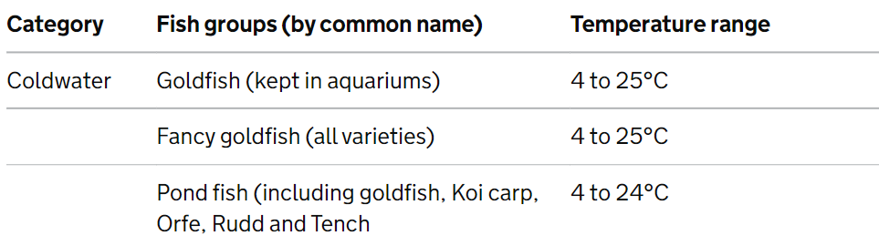
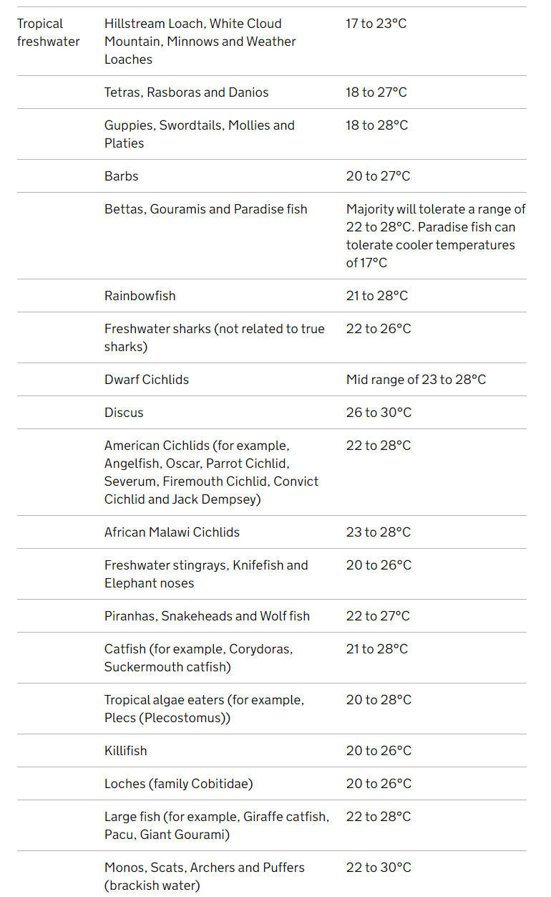
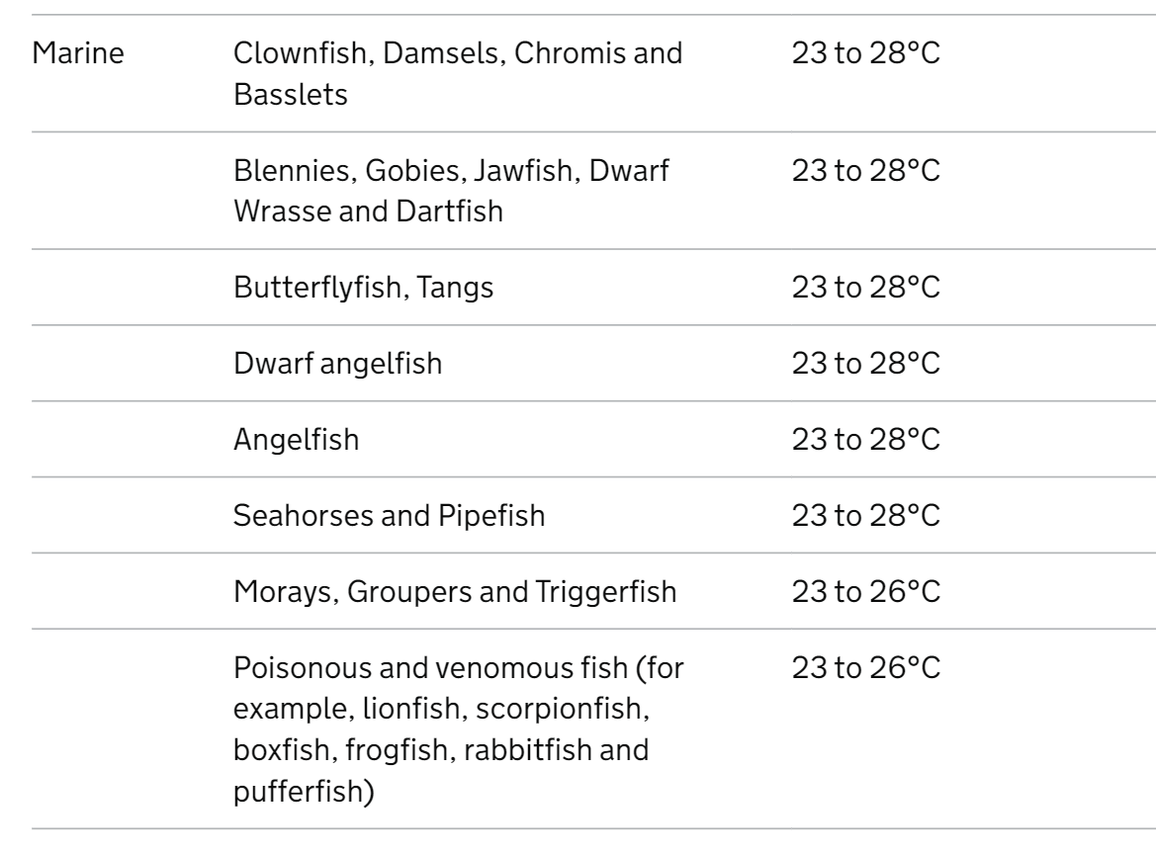

Water quality for fish

Ammonia and nitrite are toxic to fish and their accumulation must be avoided.

See the water quality standards that must be followed.

Water quality must be checked weekly and records kept of results for ammonia, nitrite and nitrate. Water testing must take place in stocked tanks.

Centralised systems must be tested weekly. 10% of individually filtered tanks or vats must be tested weekly. Testing may be via electronic means for relevant parameters. If a visual inspection of aquaria or vats indicates unusual behaviour or deaths, any necessary remedial action must be undertaken and recorded.

Fish must not be subject to sudden fluctuation in chemical composition of their water, other than for the controlled treatment of disease or as part of a controlled breeding programme. In case of doubt, expert advice must be sought.

Light for fish

Fish must be maintained on an appropriate photoperiod (day and night cycle) as far as possible.

For fish kept in outdoor ponds, vats and stock tanks shade from direct sunlight must be provided (for example, by the provision of plants or other shade).

Water quality standards

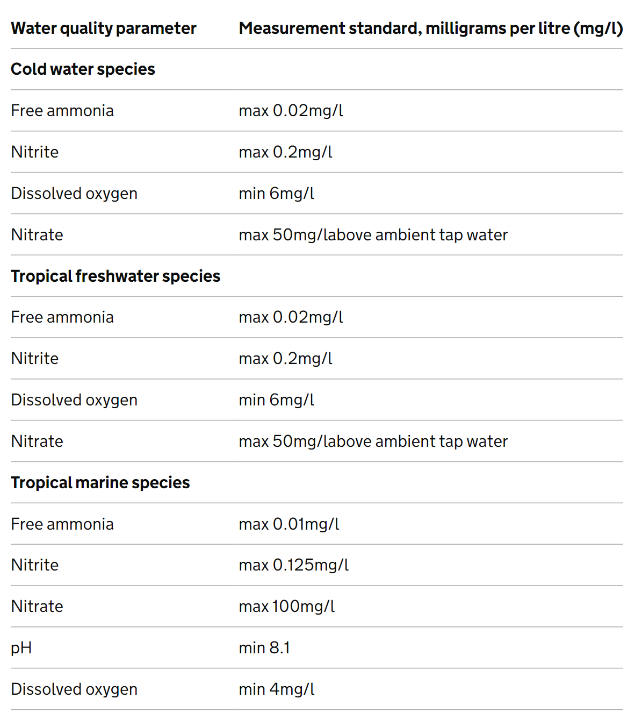

Cleaning fish

All aquaria, vats and ponds must be kept free of accumulations of suspended waste products or uneaten feed. Excess accumulation may affect water quality and therefore damage fish health. Waste material must be removed as necessary. Cleaning regimes must be sensitive to species-specific needs, as certain fish species may benefit from controlled algal build-up to facilitate grazing behaviour. Care must be taken to minimise stress during cleaning.

Accessibility to staff

Racked systems must be accessible by use of a stepladder or other such means.

Feed for fish

Food must be added directly to the tank or pond.

Required higher standards for providing a suitable environment for fish

- Water quality must be assessed 3 times weekly and records kept of test results. In instances when water quality parameters are not met, the remedial action taken to restore acceptable parameters should be recorded.

- There must be evidence that UV systems are maintained regularly.

Optional higher standard for providing a suitable environment for fish

- A suitable temperature range for the fish must be displayed on each standalone system and on each centralised system.

- For premises with no natural light, there must be automated systems or procedures (or both) to ensure gradual change in light levels.

How do you meet this standard?

Inspectors comments –

6.0 Suitable diet for fish
Fish must be fed a diet suitable for that species at an appropriate feeding rate and frequency and so as to avoid competition. For example, feeding across the whole surface of the aquaria or pond and extending feeding times.

Licence holders selling to the general public must have an understanding of the nutritional requirements of the categories of fish they sell and must advise the owner of these requirements.

Feeding fish

Given the numbers of fish that might be held in any one facility, it is not feasible to monitor and record changes in eating habits of individual fish. The feeding behaviour of groups of fish must be recorded if such behaviour changes significantly and appropriate advice obtained from a competent specialist when appropriate.

How do you meet this standard?

Inspectors comments –

7.0 Monitoring of behaviour and training of fish
Any items that get in the way of the safe and easy capture of fish must not be used or must be removed from tanks prior to capture.

How do you meet this standard?

Inspectors comments –

8.0 Fish handling and interactions
Handling must be kept to a minimum at all times.

How do you meet this standard?

Inspectors comments –

9.0 Protecting fish from pain, suffering, injury and disease
Staff must take precautions to prevent cross-contamination between aquaria or vats. Equipment (for example, nets) must normally be cleaned and disinfected between uses or dedicated to a specific tank.

Aquaria and vats must be checked daily and cleaned as often as is necessary (as determined by water quality) to maintain good hygiene standards, consistent with the rate of stock turnover and consequent stocking densities.

For fish, in-line UV treatment or other sterilising devices effectively provide a means of isolating individual tanks in multiple tank systems and are a suitable alternative to self-contained isolation facilities. They must be of an appropriate size and maintained in accordance with manufacturers’ recommendations.

Newly introduced stocks must be given an appropriate acclimatisation period, as deemed necessary, as far as possible separate from existing stocks. New stocks must be closely monitored and any disease problem which arises must be treated promptly.

Fish waste, including cadavers, may be incinerated or disposed of through general waste in sealed double-bagged plastic bags.

Fish showing signs of illness or disease may be kept with other animals provided that all the fish in the same tank (or in connected systems without a sterilisation filter) are given appropriate treatment. In cases of doubt about appropriate treatments, expert advice must be sought from a vet, competent person or fish specialist.

Anyone responsible for euthanising fish must follow recommended practices, written procedures and have been suitably trained.

In the case of fish, it is sufficient to check daily and maintain records limited to observed signs of ill health and disease. Where problems are identified, remedial action must be taken.

In cold weather, ice may form on outdoor displays such as ponds. In such cases, it is important that a hole in the ice is made by floating a plastic ball which can be removed if the water freezes (for example).

Required higher standard for protecting fish from pain, suffering, injury and disease

- The business must have in place reasonable measures to prevent the import, outbreak and spread of disease. This must be demonstrated by implementation of a biosecurity plan.

How do you meet this standard?

Inspectors comments –

Businesses consolidating imports of fish: guidance for inspectors

‘Consolidators’ refers to businesses which import live ornamental fish for the sole purpose of supplying imports directly to wholesalers and retailers. Routinely opening boxes compromises the welfare of the fish.

Aquaculture Production Businesses (APB’s) that are authorised under regulation 5(1) of the Aquatic Animal Health (England and Wales) Regulations 2009, and that are inspected by the Fish Health Inspectorate, are exempt from the requirement to have a licence.

In the case of APBs, if local authorities consider they need specialist advice they should consult the Fish Health Inspectorate who are experienced in the inspection of these businesses.

Conditions for businesses consolidating imports of fish

This section outlines the conditions that can be checked on inspection and the additional conditions that must be applied to such businesses.

When inspecting business, you should check the general conditions:

1.0 (licence display)
2.1 (type of animals to be specified)
3.3 (written training policy) - at least one designated member of staff to be on site with an understanding of current import regulations
4.10 (animals not left unattended) - fish boxes must be handed over into the care of a person competent to provide necessary care from that point. They must not be dropped off and left unattended

You should also check the follow pet sales conditions:

2.1 (register of animals) - purchase records maintained (see retailer)
2.5 (advertisements) - as retailer

Fish must be transported in accordance with International Air Transport Association (IATA) and current transport regulations. The licence holder must be able to demonstrate that they have undertaken appropriate due diligence in this regard. In particular that:

- Fish will be packed and transported according to IATA standards.

- Distributors will meet legal obligations under current welfare in transit regulations.

- Anyone transporting fish has the appropriate animal transport authorisation.

- They keep records of all imported and transported fish that enables traceability to source. This condition can be met by retaining invoices and receipts. Additional record keeping is not required.

- They allow access by the relevant authority to these records.

Have a contingency plan in place that is available to inspecting authorities and includes:

- Provision for the care of fish in the event of an accident
- Provision for the care of fish in the event of failure to deliver (for example, delayed delivery)
- Emergency contact telephone numbers

Required higher standards for buying and selling fish

- Businesses must have:

  - documented procedures that control and manage the buying and selling of fish
  - internal controls in place to detect irregular transactions
  - a well-maintained accounting system with a full audit trail

Inspectors Comment -

Inspectors check list to award the Higher Standard

100% of the required higher standard and at least 50% of the optional higher standard are required.

Required higher standards for providing a suitable environment for fish

- Water quality must be assessed 3 times weekly and records kept of test results. In instances when water quality parameters are not met, the remedial action taken to restore acceptable parameters should be recorded.

- There must be evidence that UV systems are maintained regularly.

Required higher standard for protecting fish from pain, suffering, injury and disease

- The business must have in place reasonable measures to prevent the import, outbreak and spread of disease. This must be demonstrated by implementation of a biosecurity plan.

Required higher standards for buying and selling fish

- Businesses must have:

  - documented procedures that control and manage the buying and selling of fish
  - internal controls in place to detect irregular transactions
  - a well-maintained accounting system with a full audit trail
Optional higher standard for providing a suitable environment for fish

- A suitable temperature range for the fish must be displayed on each standalone system and on each centralised system.

- For premises with no natural light, there must be automated systems or procedures (or both) to ensure gradual change in light levels.

Has the higher standard been achieved? Yes/No

Inspectors additional comments:

Inspectors Name: Date of inspection:

Inspectors signature:

First payment received: £ Received by:

