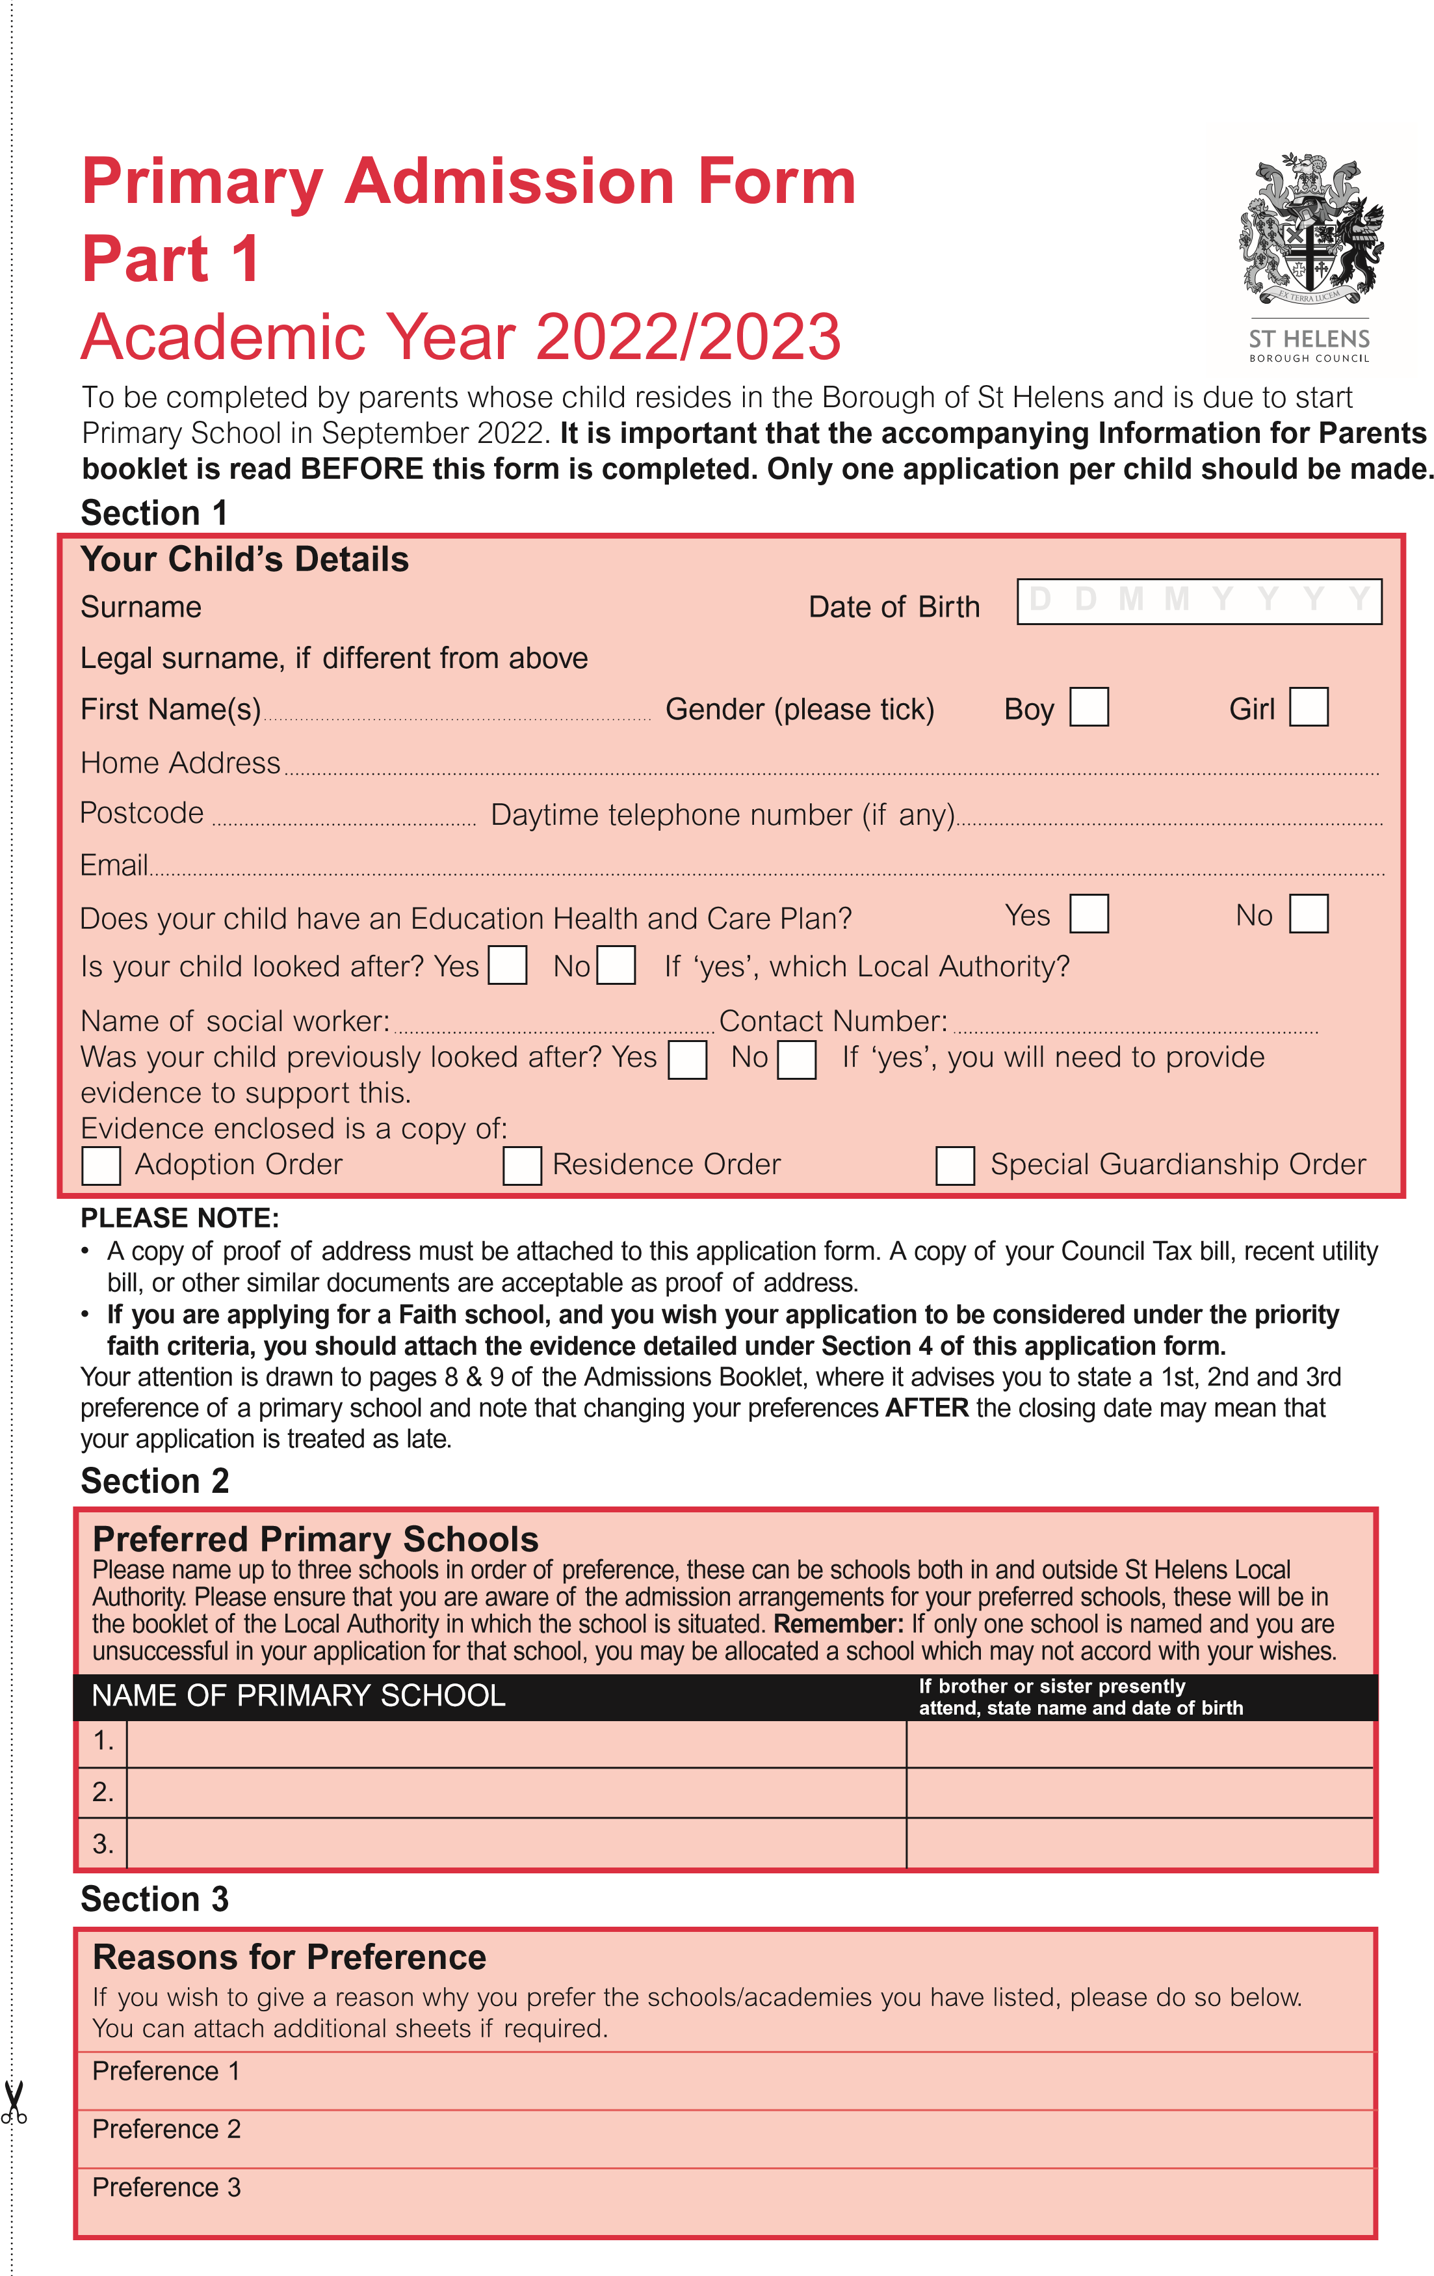

# Section 4

If any of your three stated preferences is for a Voluntary Aided Primary School, please ANSWER the questions below. (If you apply for a Voluntary Aided School outside St Helens, please **check** whether

the school requires you to complete a supplementary information form.)

# Applicants for Catholic Primary Schools only

1. Is your child baptised Catholic? Yes No

Date of Baptism

Church of Baptism

Catholic Parish of residence

**Please attach a copy of your child’s Baptismal Certificate. If you do not have a certificate and your child was baptised in the parish which the school serves, then the parish baptismal records will be checked by the school to confirm baptism. If your child was baptised in another parish and you do not have a certificate, you will need to obtain proof from the relevant parish to confirm that your child is a baptised Catholic.**

1. Is your child baptised in another Christian Faith? Yes No

Date of Baptism

Church of Baptism

**If yes, please attach a copy of your child’s Baptismal Certificate**

1. Is your child a member of another Faith group? Yes No

**If yes, please attach a letter from the appropriate Minister of Religion**

# Applicants for Church of England Primary Schools only

Do you wish your child’s application to be considered under the higher priority church attendance category (as detailed in the school’s oversubscription criteria)? Yes No

**If yes, please attach a letter from the appropriate Minister of Religion or religious leader to confirm church attendance.**

In the event that during the period specified for attendance at worship the church has been closed for public worship and has not provided alternative premises for that worship, the requirements of these arrangements in relation to attendance will only apply to the period when the church or alternative premises have been available for public worship.

Has your child any special medical or social needs? Yes No

**If yes, please attach a letter from a registered health professional or social worker at the time of application. (The supporting letter or report must set out the particular reasons why the school is the most suitable and the difficulties that would be caused if the child had to attend another school.)**

