Healthy Holidays

We all know that kids are a prone to graze food during the holidays.
We will look at how we can keep this on a budget and healthy.

Snack box.
You will need a box per child.
This can be decorated / personalised by the child.

With the child you agree how many snacks a child may have.
At the beginning of the week (or agreed time) fill the box with snacks, the box is to be filled once a week, so if the child eats them all in a few days they will not be replenished.
This helps you managed a budget and limit the amount of snacks a child is having.

Suggestions include:
Crisps under 100 calories which include:
Wotits
Qualvers
Hoola hoops
Maize / corn based snacks
Butterkist pop corn.
2 finger kitkat
Sugar free jelly
Homemade popcorn
Cheese strings
Blue ribbon
Mini milk icecream
Mini bag haribo
Mini iced rings
Light baby bel
Low fat cheese triangles and crackers
Fun size chocolate bars

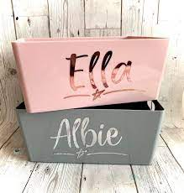

Have a fruit bowl at easy access for the child.
Chopped up fruit in the fridge may encourage children to eat in.
Create fun fruity ice cubes to reduce the number of sugary drinks.
Keep the biscuit tin out of reach to reduce temptation.

